What is a Web Application?

In this tutorial, we will learn the basic concepts of a web application, how it works, its advantages and disadvantages.

Definition of Web-application

A web-application is an application program that is usually stored on a remote server, and users can access it through the use of **Software** known as **web-browser.**

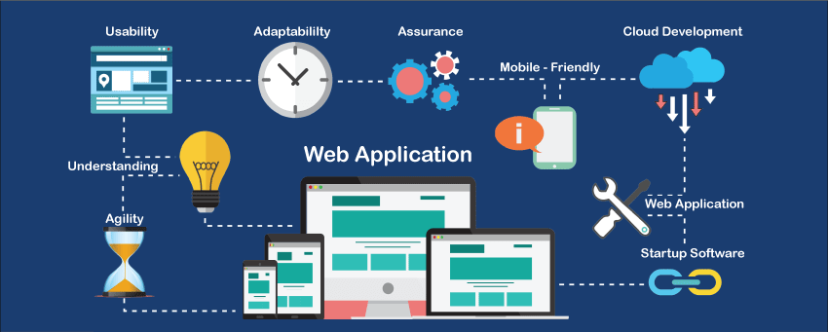

Another definition

It is a type of computer program that usually runs with the help of a web browser and also uses many web technologies to perform various tasks on the internet.

A web application can be developed for several uses, which can be used by anyone like it can be used as an individual or as a whole organization for several reasons.

In general, a web application can contain online shops (or we can also say them e-commerce shops), webmail's, calculators, social media platforms, etc. There is also some kind of web application that usually requires a special kind of web browser to access them. We cannot access those kinds of web applications by using regular web- browsers. However, most of the web applications available on the internet can be accessed using a **standard web browser**.

If we talk about the web application in general, a web application usually uses a combination of the server-side scripts such as [**PHP**](https://www.javatpoint.com/php-tutorial)**, ASP,** for handling the information/ data storage and retrieval of the data.

Some of them also use the client-side scripts such as [**JavaScript**](https://www.javatpoint.com/javascript-tutorial)**,**[**HTML**](https://www.javatpoint.com/html-tutorial) to represent the data/information in front of the users, and some of the web applications are also using both **server-side** and **client-side** at the same time.

It allows the users to communicate with the organization or companies by using the online form, online forums, shopping carts, content management system, and much more.

Apart from that web applications also allow its users to create documents, share them, or share the data/ information. By using the web application, users can collaborate on same projects by event when they are not available on the same geographical location.

After knowing that what a web application is, there may be a question hitting in mind that how it will work.

Let's understand the working of the web-application.

How does a web- application work?

In general, web-application does not require downloading them because, as we already discussed, the web application is a computer program that usually resides on the remote server. Any user can access it by using one of the standard web browsers such as [**Google Chrome**](https://www.javatpoint.com/google-chrome)**, Safari, Microsoft Edge, etc.,** and most of them are available free for everyone.

A web applications are generally coded using the languages supported by almost every web-browsers such as HTML, JavaScript because these are the languages that rely on the web browsers to render the program executable.

Some of the web applications are entirely static due to which they not required any processing on the server at all while, on the other hand, some web applications are dynamic and require server-side processing.

(Static means directly we get the data form the html page like about us And dynamic means that library example in which librarian will fetch the 3 books from the database)

To operate a web- application, we usually required a web server (or we can say some space on the web-server for our programs/application's code) to manage the clients' upcoming requests and required an application server.

The application server performs the task that requested by the clients, which also may need a database to store the information sometimes. Application server technologies range from [**ASP.NET**](https://www.javatpoint.com/asp-net-tutorial)**, ASP**, and **ColdFusion to PHP and JSP**.

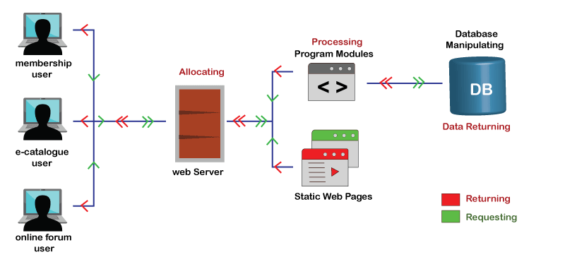

A standard web application usually has short development cycles and can be easily developed with a small team of developers. As we all know, most of the currently available web applications on the internet are written using the programming languages such as the **HTML (or HyperText Markup Language),**[**CSS( or Cascading Style Sheets)**](https://www.javatpoint.com/css-tutorial)**, and Javascript** that are used in creating **front-end interface (Client-side programming).**

To create the web applications script, server-side programming is done by using programming languages such as **Java, Python, PHP, and Ruby,** etc. **Python** and **Java** are the languages that are usually used for server-side programming.

The Flow of the Web Application

Let's understand how the flow of the typical web application looks like.

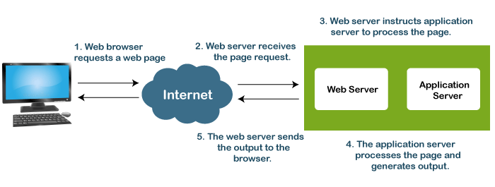

1. In general, a user sends a request to the web-server using web browsers such as **Google Chrome, Microsoft Edge, Firefox**, etc. over the **internet**.
2. Then, the request is forwarded to the appropriate web **application server** by the **web-server**.
3. Web application server performs the requested operations/ tasks like **processing the database, querying the databases; produces** the result of the requested data.
4. The obtained result is sent to the web-server by the web application server along with the requested data/information or processed data. (app server ->web server)
5. The web server responds to the user with the requested or processed data/information and provides the result to the user's screen.

## Main Flow

User request send to Web Browser ->Web browser receives ->sends to the app server->process the page ->response to the browser ->browser response to the client.

Benefits of a web application

Let see some of the significant benefits offered by a web application:

* Any typical web application can run or accessible on any operating system such as the Windows, Mac, Linux as long as the browser is compatible.
* A web application is usually not required to install in the hard drive of the computer system, thus it eliminates all the issues related to the space limitation.
* All the users are able to access the same version of the web application, which eliminates all compatibility issues.
* It also reduces software piracy in subscription-based web applications, for example, **SAAS (or Software as a service).**
* They also reduce the expense for end-users, business owners because the maintenance needed by the business is significantly less.
* Web applications are flexible. A user can work from any geographical location as long as he has a working internet connection.
* It just takes a moment to create a new user by providing a username, password, and URL, and it's all.
* After the availability of the cloud, storage space is now virtually unlimited as long as you can afford it.
* A web application can be programmed to run on a wide variety of operating systems, unlike native applications that can run on a particular platform.
* Any standard web application is developed with some basic programming languages like HTML, CSS that are compatible and well known among the IT professionals.

Disadvantages of the Web Applications

As we all know, there are two sides of anything; if something has some advantages, it may also have limitations/ disadvantages. Consider the following disadvantages of the web applications.

* Internet connection is necessary to access any web application, and without an internet connection, anyone can't use any of the web applications. It is very typical to get an internet connection in our modern cities, still rural area internet connectivity not so well.
* Several people in business believe that their data on the cloud environment is no that secure and likes to stick with old methods; they even don't want to use new methods.
* As we all know that many users like to use different web browsers according to their needs and choices. So while creating a web application, you must remember that your application must support several web browsers, including new and old versions of browsers.
* Speed-related issues are also affecting the web application's performance because there are several factors on which the performance of a web application depends, and these all factors affect the performance of the web application in their own way.
* If a user's web application faces any kind of issues, or if he does not have a good quality corporate website, his web application will not be going to run correctly, smoothly.
* A user must have to spend enough money to maintain the good condition of his web application, provide an update whenever an issue occurs, and make an attractive user interface, which is not so cheap at all.
* A web application must be programmed/ coded in such a way that it will be run regardless of the device's operating system.
* A web application may face some issues while running on Windows, Android, or several other operating systems if it is not responsive.

There are several advantages and disadvantages of web applications; it is impossible to discuss them all at once. So in the above, we only discussed some critical and useful points that may help you quickly understand the pros and cons of the web application.

* Notes
* **What is a remote access server?**
* A server that is dedicated to handling users that are not on a LAN (Local Area Network) but need remote access to it. The remote access server allows users to gain access to files and print services on the LAN from a remote location. For example, a user who dials into a network from home using an analog modem or an ISDN connection will dial into a remote access server.

**Difference between Web Server And App server**

* Web Server is designed to serve HTTP Content. App Server can also serve HTTP Content but is not limited to just HTTP. It can be provided other protocol support such as RMI/RPC

Web Server requests page from the application server and application server process the page And then it response to the web server.